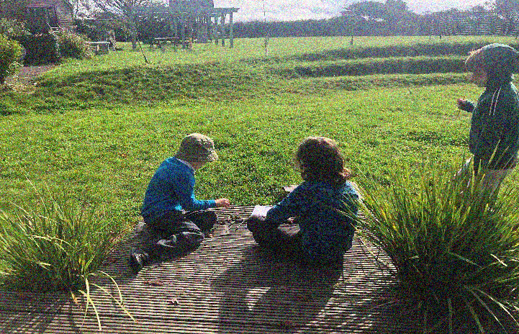
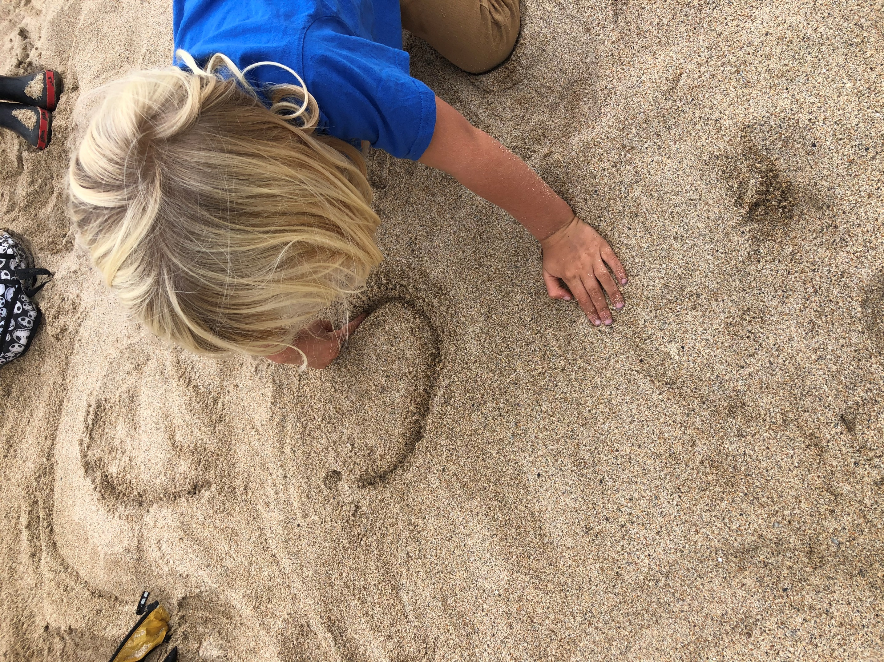
Look no further for a reception place for your child for September 2024 Nysgerrig Kindergarten and Forest school
welcomes you to our
open afternoon on 6th November 2023
From 1.30pm – 3pm come and join in with our inquiry led learning in our rich, vibrant, indoor and outdoor learning environment, near Praa Sands.
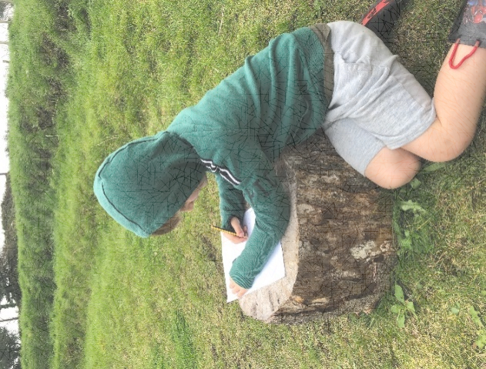
Learn all about our Reggio Emilia inspired and unique Nysgerrig approach to Early years education. School reception places are available for this year and for next. We also take children from 3 years old, funded places available.
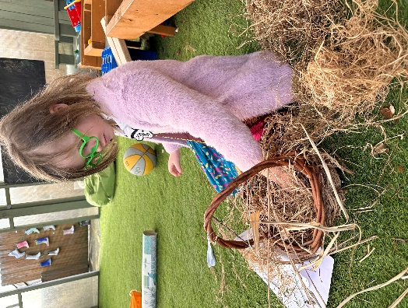
CALL US NOW on 01736 763310
To book a free place for you and your child

