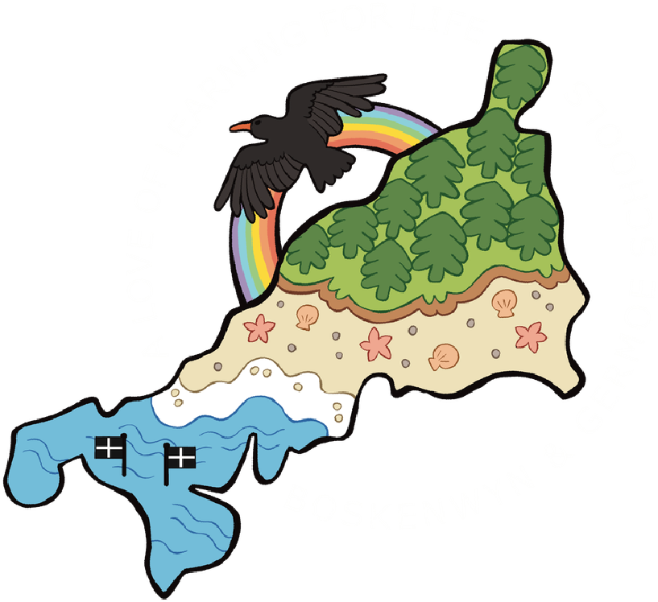

Germoe School Newsletter
10th July 2026
MESSAGE FROM MISS BLACKBURN
Dear parents and carers,
Another wonderful, although hot week at school! We welcomed a group of Romanian students and their teacher who enjoyed their time visiting our wonderful school and
travelling out to the local beauty spots such as St Michael’s Mount, Lizard Point and Land’s End.
Don’t forget it is sports’ day and school fair next week. Please ensure your child has appropriate sport shoes on, has a water bottle, hat and sun protection with them.
Be careful in the sun over the weekend, UV levels are high (7) which is high risk, particularly between 1200 and 1500 so make sure you are well protected.
Have a safe and enjoyable weekend
Paula Blackburn
As a school which likes to spend a lot of time outside it is important that children are always ready for this.
Our school uniform is: sweatshirt/navy jumper or cardigan,
polo shirt/ t-shirt, white/light blue
navy/black trousers/joggers/leggings/skirt blue school summer dresses
In the interest of safety please also ensure children are: wearing closed-toe shoes, not slip-ons only wearing stud earrings
Not wearing fake nails
In the warm weather we have been having recently we also strongly recommend children bring a hat and suncream with them to school, along with a water bottle.

LIBRARY
🌟 Help Us Build a Bright, New School Library! 🌟
We will soon start creating our beautiful, naturally lit reading space for the children, and we need your help to bring this project to life!
We are currently seeking donations of FREE double-glazed windows and doors. ✂ Our Ideal Sizes:
Windows: 2× opening windows in frames (approx. 1m × 1m)
Doors: 1× pair of outward-opening, fully glazed double doors (approx. 2.1m high × 1.5m wide)
Have slightly different sizes? Please get in touch anyway—we would love to consider alternatives to help complete this project!
📞 Ready to Donate, or know someone who will? Contact Ben on 07710734233 with any details.

ABSENCE REQUESTS
If your child is due to be absent during term time, an absence request form will need to be completed. This can be collected from the office. Please ensure these are handed back in 3 weeks before the proposed absence as they need to be shared before a decision can be made around whether it is authorised

SCHOOL MONEY DEBTS
Please can we ask that any outstanding debts on school money are paid in full as soon as possible, especially those pupils that will be leaving us at the end of this term. All school money accounts need to be brought up to date before we break up for the summer holidays.
Thank you

FROGS
Thank you to everyone who have helped out and donated with FROGS June to July has been a whirlwind! So I'm now catching up!
We raised £80 at Germoes Got Talent!
Wind and the Willows performances we made £193.90!
Thank you so much to everyone for supporting FROGS, helping out and donating we can't raise funds for the children without you all. As you all know many of us Year 6
parent/FROGS are leaving end of July and we need to hand the baton over to you! Il be arranging a meeting for this soon so please come so FROGS can continue forward.
Next update will be after Sports Day/Summer Fayre see you all there on the Tuesday 14th July! Keep eyes on the FROGS and Germoe Socials WhatsApp groups.
Cheryl

FROGS
We have a couple asks for the Summer Fayre, we really need donations for the Tombola things like sweets toys or regifts for example.
Also please could you save any jam jars for the jolly jars.
❤🫙Jolly Jars Needed! 🫙❤
For this to be success, we need you all to help create jolly jars for prizes on the stall. Prize every time.
Have fun creating a jolly jar with your child.
Clean an empty jam jar. Lid needed.
Put in sweets , chocolates, craft supplies, stickers, stationery..... anything you think a child would like. Doesn't have to be full.
Decorate if you fancy it, but doesn't have to be. Bring in sealed. The more the merrier.
Cheryl Richards
DIARY DATES
Tuesday 14th July
Sports Day @ 1.30pm

Summer Fayre
Monday 20
July
th
Leavers Service
Thursday 23
July
rd
Break up for summer
AFTER SCHOOL CLUBS
(
all clubs are from Y1-Y6 unless otherwise stated
)
Please note this is the final week for after school clubs - other than Wraparound
Care
Monday
Miss Symons - Rounders
Mrs Sukstiene - Bookclub
Tuesday
Miss Burns- Recorders
Mrs Knight- Computing

Mr Conway- Cricket
Thursday
Miss Faucher - Art

DONATED BRAND NEW SHOES/TRAINERS
We have kindly been given some brand new shoes/trainers that are still in the box. If you are interested please pop into the office.
WRAPAROUND CARE

Breakfast Club available from 8am and after school care until 4:30pm daily

SOUNDS WRITE
https://sounds-write.co.uk/decodables-help/
Please use the link to a course about how to support your children with their reading at home an explanation of how Sounds-Write books work, (if parents would like to)
WHERE TO FIND INFORMATION
https://www.germoe.cornwall.sch.uk/web/parent_information_finder/

DONATED UNIFORM
We have a selection of trousers, skirts, polo shirts, t-shirts, jumpers, tracksuits that have been donated and are free to a good home. If you are looking for some
uniform please come to the office
RINSEY CLASS UPDATE
In Maths we were learning about bar charts and pictograms. In Science we were doing
experiments and music we were making our own songs in groups. In English we were
doing character descriptions.
PARKING PROBLEMS - WE NEED YOUR HELP!
We have a lot of cars trying to drop off and collect children twice a day. We don't have much space, and the car park often gets congested.
We have a large pile of logs in the corner of the car park that needs to be gone. Please help yourselves to wood! We also have a pile of rubble in the driveway - is anyone able to help clear this?
We also need your help for ideas. What suggestions might you have that would help to solve our parking problems? Follow this link to have your say - Germoe School Parking Solutions Survey – Fill in form https://forms.cloud.microsoft/e/cSEKQnWvyA
TWITTER AND INSTAGRAM
The Federation of Germoe and Boskenwyn Schools are on twitter and Instagram!
Twitter: @BoskenwynGermoe
Instagram: boskenwyngermoe
Feel free to follow us and spread the word to encourage others to hear about the
wonderful things happening in our schools.

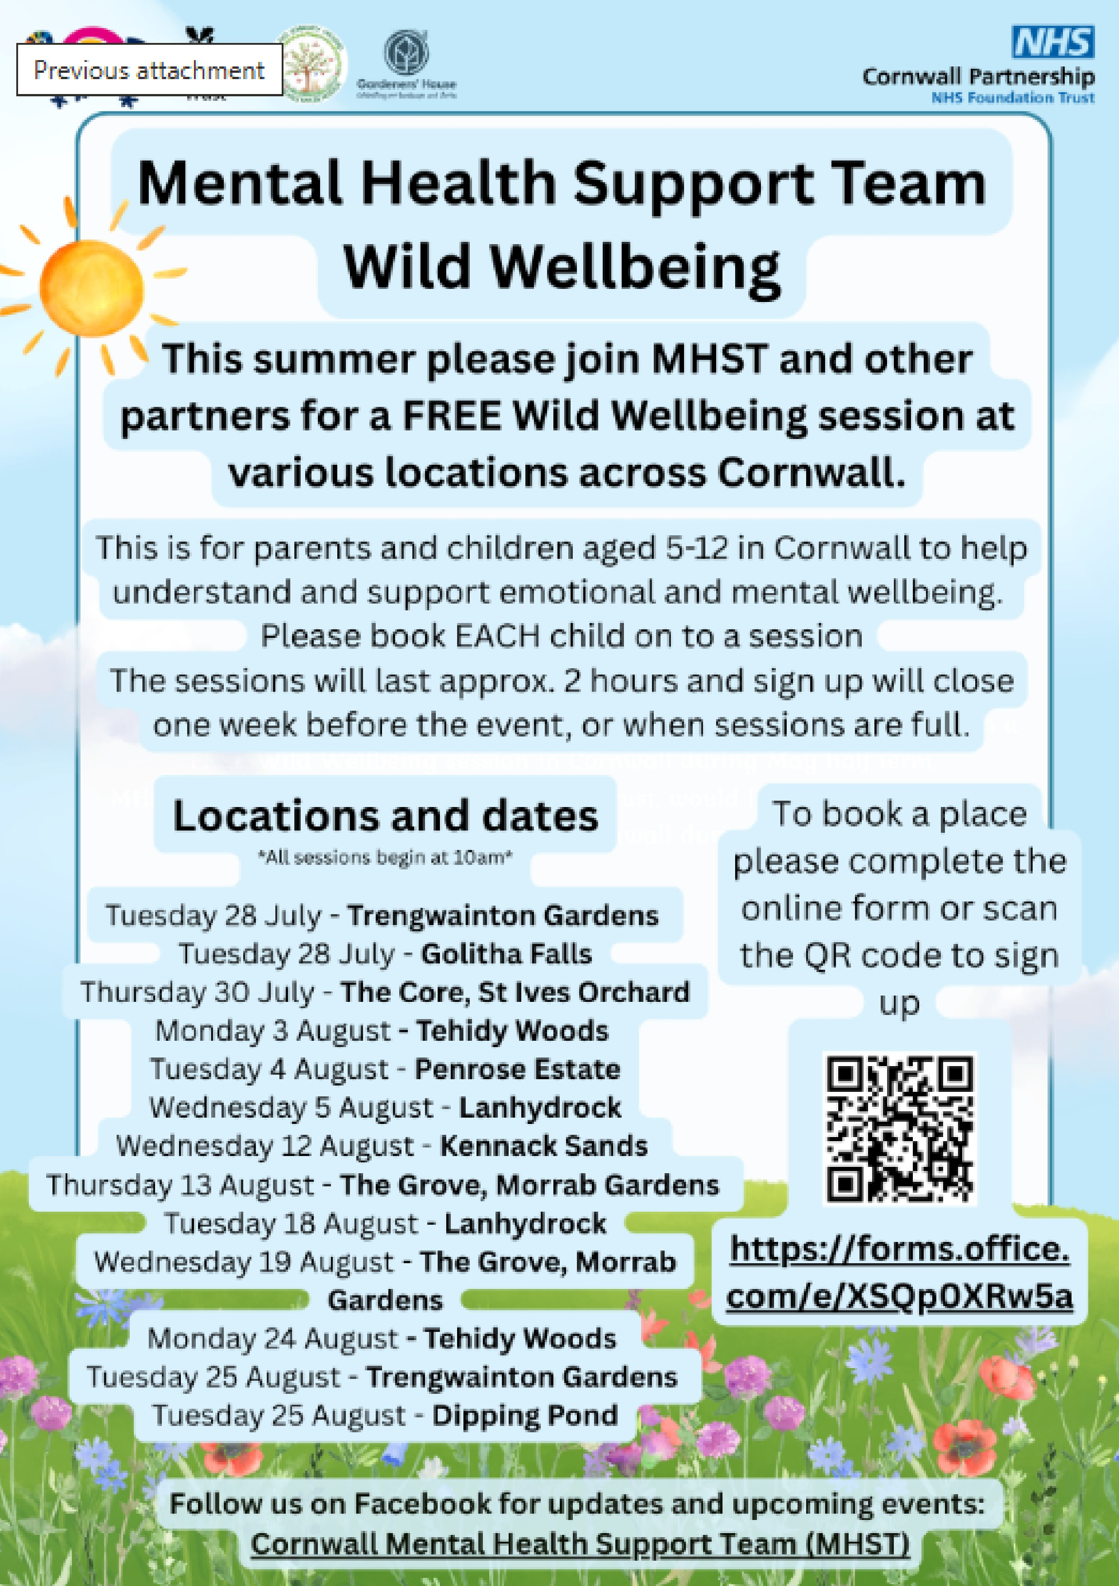
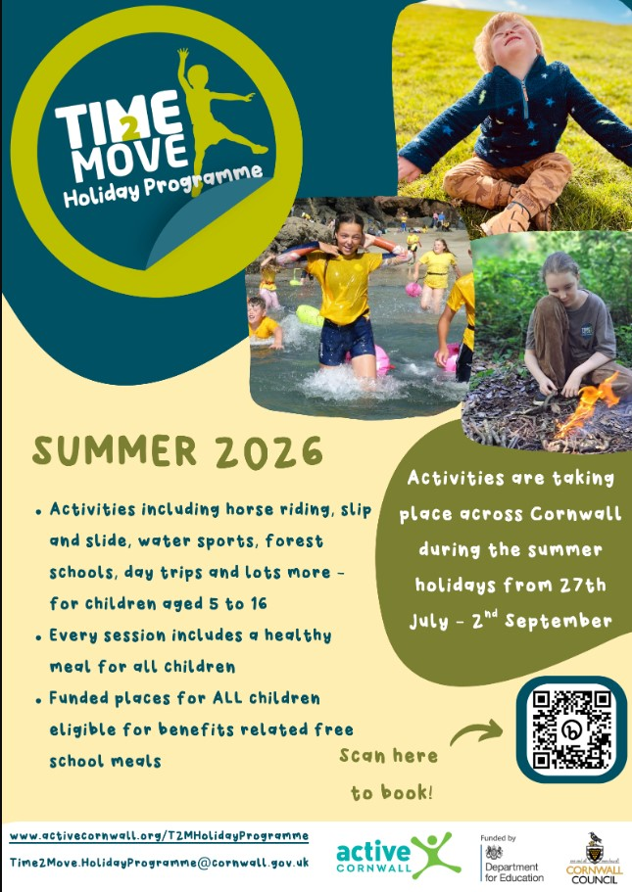

The Time2Move Holiday Programme will offer fun physical activities, games and wider activities plus a hot meal for all children at lunchtime.
Activities will be taking place across the School Holidays and is available to all children aged 7 to 16 years. Places are limited to 80 per day so booking is essential.
During the sessions, children will be able to take part in a variety of activities such as: - Football
- Basketball
- Soft Archery & Nerf Guns
- Badminton
- Netball
- Dodgeball
- Karaoke
- Crossbow & Laser Tag- Dodgeball/Benchball & Kinball Sessions run from 10am to 2pm.
Each day the fantastic team in the Humphry Davy School Kitchen will be providing lunch and fruit for all children that attend. Please make sure you write on the registration
forms if your child has any special dietary requirements and we will liaise with the team
to make sure they can still enjoy a hot meal. If you would prefer to send your child with a packed lunch that is absolutely fine.
Each day please send your child/children wearing comfortable clothes and shoes to be able to run around in, a refillable water bottle, any medication they may need clearly marked and a coat in case the weather allows us to go outside for activities.
24th -26th August 26

https://playwaze.com/humphry-davy-school/4r399obbm919xd/session-display?
eventId=PhysicalEventSeries%2F131046-B&overrideAdminView=True

