**PASSIONATE ABOUT THE TEENAGE BRAIN**

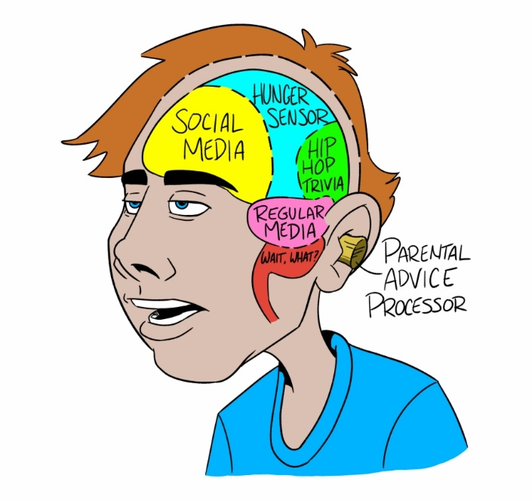

**For Parents/ Carers of young people aged 12 to 17 years**

**Delivered over 3 sessions (1.5 hours per** **session)** **Delivered online with Microsoft teams**

**On Tuesdays 19th and 26th January and 2nd February**

**at 6:00-7:30 pm**

Sessions Include:

• Promoting Understanding of the Teen

Brain

• How to build better relationships with

our young people

• To develop strategies to support

behaviour management

• To give support and information to

parents and carers

To book a place please complete the Early Help 'Request for Help' booking form on the link below:

[www.cornwall.gov.uk/earlyhelphub](http://www.cornwall.gov.uk/earlyhelphub)

Click on ’Request for Help’ then on the request for help form. Complete, save

and email to [earlyhelphub@cornwall.gov.uk](mailto:earlyhelphub@cornwall.gov.uk)

