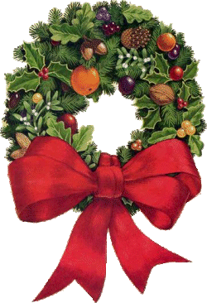
Germoe School Christmas Fair
Monday 12th December 2 – 4pm

Organised by the children of The School Council

Please support us – come and enjoy:
Games Sweet Treats Refreshments Crafts Jewellery Books
and much, much more ….

