Germoe Community Primary School
Newsletter for Week Commencing 27th June 2016
daTE | AFTER SCHOOL CLUBS at germoe
Mon | KS1 Beginners Recorder – Miss Burns / Drama – Mr Taylor Moore
Tues | Rounders – Mr Conway / Sailing
Wed | Dodgeball – Mr Conway / Jump With Jo
Thurs | Film Club KS1 Mrs Jones & KS2 Mrs Larcombe
Fri | Alive

OTHER INFORMATION/ADVANCE NOTICES
PLEASE NOTE THE LEAVERS LUNCH WILL BE AT 12.00 AND NOT 2.30PM
- Germoe Leavers Lunch – Thursday 7th July- Menu
Beef or Quorn Burger in a Bun OR
Pork or Quorn Sausage in a Roll
Served with Chips, Coleslaw and Pasta Salad
****
Mango Sorbet OR
Shortbread Biscuit and Fresh Fruit Wedges
- Those taking part in after school Sports clubs and P.E are asked to please remember their kits. Anyone who doesn’t have their P.E kits will have to stay next to Mr Conway and not participate. Thank-You.

- Amended date for Sports Day is Wednesday 29th June 2016. If the weather is against us, we will need to postpone Sports Day until the 12th July. Everyone welcome.

- Please see attached for term dates for next year (2016/2017) including INSET days.

- If your child is attending the Hubbub Music festival at Heartlands on Tuesday (28th) could you please ensure they are at school for 8.30am as we will need to leave promptly to arrive for 9.30am. Younger siblings are able to join Mr Conway’s breakfast club that morning.

- Class 1 are going Horse riding on Monday 27th June. Please remember to pack an extra drink. It should be a very enjoyable day!
- Thank you Mrs Jones - The children have had a fantastic Sports Week thanks to Mrs Jones' co-ordination. The children have taken part in judo, rounders, 'horse riding', archery, football, dodgeball, to name but a few of fantastic sports on offer this week. We have shared some of our sporting activities with Boskenwyn and everyone has had a wonderful time. Thanks Mrs Jones!
- Sports week has been a great success. I will be uploading photos very soon, please got to the ‘sports’ tab on the school website to have a look at some fantastic action shots. At time of writing KS2 are gearing up for their rounders match against Boskenwyn later today. Results will be announced online later in the week. Good Luck Germoe! Mrs Jones.
- Please note that there are a couple of changes to the after school clubs. Jump with Jo is moving to Wednesdays after school until the end of term, and dodgeball will be for KS2 only. This is with effect of next Wednesday (29th).

- Mrs Winter has almost single headedly produced a most wonderful structure for our Mazey Day parade tomorrow. We look forward to accompanying Slinky Dog through the streets of Penzance and showing off the formidable talents Germoe School has to offer. Here's a sneak preview of Slinky when almost complete on Thursday.

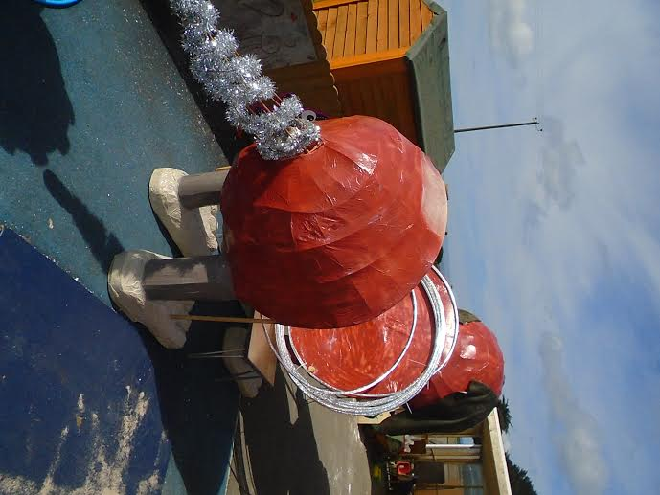
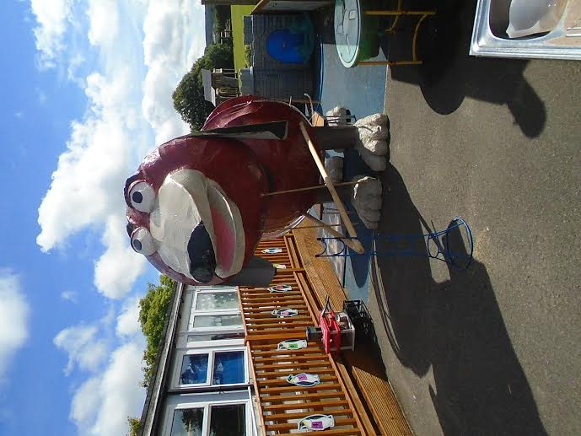

*STARS OF THE WEEK*

EYFS – Harley, For Super Concentration.
SENNEN CLASS – Sophie, For Being A Good Sport And Always Trying Her Best.
KYNANCE CLASS – Charlie, For Excellent participation In All Areas Of School Life.
GODREVY CLASS – Anneliese, For Helping Others With Their Learning.
Diary Dates
June
Monday 27th Class 1 Trip Horse Riding.
Tuesday 28th Class 2/3 Trip to Heartlands for ‘Hubbub’ festival.
Wednesday 29 Sports Day
July
Monday 4th Parent/Governor Meeting Germoe @ 9am
Wednesday 6th Summer Production @ 2pm Germoe & 6pm Boskenwyn
Thursday 7th Leavers Lunch @ 12.00
Friday 8th Parent Information Meeting (Staffing etc for next term) Germoe – 2.30pm.
Tuesday 12th Reserve Sports Day
Thank you for your support!

