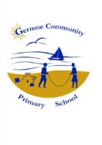
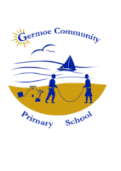

Germoe Community Primary School
Newsletter for Week Commencing 18th July 2016
daTE | AFTER SCHOOL CLUBS at germoe
Mon | Drama – Mr Taylor-Moore
Tues
Wed
Thurs
Fri

OTHER INFORMATION/ADVANCE NOTICES

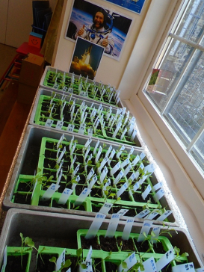
- School Council - A very big THANK YOU to all of our fantastic school councillors. They have worked hard all year, giving their time to make sure our children's voices are heard in school. We have them to thank for the Christmas Fair, danceathon and cream tea. The have raised £121.86 which we will spend next year. We are hoping to re-form our parent teacher association, 'Friends of Germoe School' to work in conjunction with School Council, to bring even greater things next year.

- Space Seeds - We have now submitted our data for the rocket space seeds experiment that has been running over the summer term. We made predictions and made comparisons between our two sets of seeds during the experiment. Both sets of our seeds seemed to grow in a similar way. In September, we should get the national results which may indicate clearer differences, or not - it will be interesting to see. Watch this SPACE!!!!

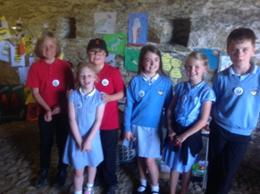
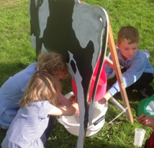
- KINGFISHER AWARD - Big congratulations to all the children who entered work into the Kingfisher award scheme. Your work looked amazing and you showed how much you had learned about sustainable farming and respect for wildlife. Thank you to all pupils and parents who made it to the award last night. I was proud of all of you when you explained your knowledge to not one but three judges. It was also fun and enjoyable and the weather certainly played its part. I have happy memories of children apple bobbing but wonder how many will have dry school uniforms to wear today? Each child who participated in the scheme has their own certificate –
Well done all of you! Mrs Rusga.
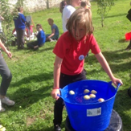

- Plastic Carrier Bag - Could all children bring a plastic carrier bag on Monday to take things home from school.

- School Dinners - Next week it will be Week 3. Also Tuesdays choice will be pasties rather than the options stated. Thanks.

- Single Equality Plan Impact Assessment – Due to the effectiveness of our federated single equality plan, there have been no incidents reported in the last 3 years.

- Due to the last day of term being on Tuesday there will be NO sailing on this day. Thank – You.

- Thank you all for your continued support this year, we hope you all have a fantastic summer and we look forward to seeing you all in the Autumn.

- Good Luck to all of the Year 6’s as they venture off on their next exciting adventures, we hope you keep in touch with how you all get on.

*STARS OF THE WEEK*

EYFS – All of EYFS! For Being Super All Year!
SENNEN CLASS – Logan, For Trying His Best In His Sports Day Races.
KYNANCE CLASS – Amy, For Her Confidence And Willingness To Take Part In All Aspects Of School Life
GODREVY CLASS – Katie, For Her Consistently Good Attitude Towards Learning And Her Caring Attitude.
Diary Dates
July
Tuesday 19th Last Day Of Term!
September
Monday 5th First Day Back After Summer!
Thank you for your support!

